**PROBLEM NUMBER : 7**

**PROGRAM:**

#include <stdio.h> // Name: Sonali Kumari

#include <unistd.h> // Rollno. : 39

#include <stdlib.h> // Sec: CE

#include <sys/types.h> // Uni Rollno. : 2017381

#include <sys/wait.h>

int main() **OUTPUT:**

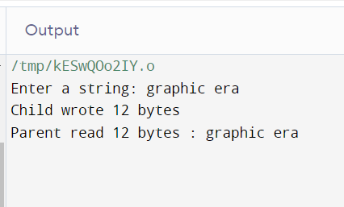{

pid_t pid;

char arr[100],str[100];

int fd[2],nbr,nbw;

pipe(fd);

pid=fork();

if(pid==0)

{

printf("\nEnter a string: ");

fgets(str , 100 , stdin);

nbw=write(fd[1],str,strlen(str));

printf("Child wrote %d bytes\n",nbw);

exit(0);

} else

{

nbr=read(fd[0],arr,sizeof(arr));

arr[nbr]='\0';

printf("Parent read %d bytes : %s\n",nbr,arr);

}

return 0;

}

**PROBLEM NUMBER : 8**

**PROGRAM:**

#include <stdio.h> // Name: Sonali Kumari

void sort(int a[][2],int n) // Rollno. : 39

{ // Sec: CE

for(int i=0;i<n;i++) // Uni Rollno. : 2017381

{ for(int j=i+1;j<n;j++)

{ if(a[i][0]>a[j][0])

{

int t=a[i][0];

int k=a[i][1];

a[i][0]=a[j][0];

a[i][1]=a[j][1];

a[j][0]=t;

a[j][1]=k;

}

}

}

}

int main(){

int n;

printf("Enter the no. of process :");

scanf("%d",&n);

int arr[n][2];

for(int i=0;i<n;i++)

{

printf("\n enter the arrival and burst time for the %dth process\t",i+1);

scanf("%d%d",&arr[i][0],&arr[i][1]);

}

sort(arr,n);

int wait[n],tat[n],averageWait=0,averageTAT=0;

wait[0]=0;

for(int i=1;i<n;i++)

{

wait[i]=wait[i-1]+arr[i-1][1];

averageWait+=wait[i];

}

for(int i=0;i<n;i++)

{

tat[i]=wait[i]+arr[i][1];

averageTAT+=tat[i];

}

double a=averageTAT/(1.0*n), b=averageWait/(1.0*n);

printf("Process no.\t Arrival time \t Burst Time\t Waiting Time \t Turn around Time\n");

for(int i=0;i<n;i++)

{

printf("%d\t\t %d\t\t %d \t\t %d \t\t%d\n",i+1,arr[i][0],arr[i][1],wait[i],tat[i]);

}

printf("The average wait time is: %lf and the average turn around time is: %lf",b,a);

return 0;

} **OUTPUT:**

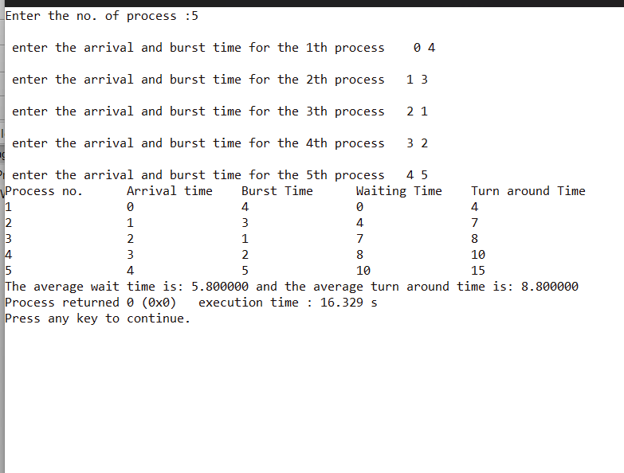

**PROBLEM NUMBER : 9**

**PROGRAM:**

#include <stdio.h> // Name: Sonali Kumari

int main() // Rollno. : 39

{ // Sec: CE

int n; // Uni Rollno. : 2017381

printf("Enter the no. of process:");

scanf("%d",&n);

int arr[n][2],burst[n];

for(int i=0;i<n;i++)

{

printf("\n enter the arrival and burst time for the %dth process\t",i+1);

scanf("%d%d",&arr[i][0],&arr[i][1]);

burst[i]=arr[i][1];

}

int wait[n],tat[n],prev[n];

int t=0,averageTAT=0,averageWait=0;

for(int i=0;i<n;i++){

wait[i]=0;

prev[i]=0;

}

while(1)

{

int ind=0,mini=100000;

for(int i=0;i<n;i++){

if(t>=arr[i][0]&&mini>arr[i][1]&&arr[i][1]>0)

{

mini=arr[i][1];

ind=i;

}

}

if(mini==100000)

break;

arr[ind][1]-=1;

wait[ind]+=t-prev[ind];

t++;

prev[ind]=t;

} for(int i=0;i<n;i++) {

tat[i]=wait[i]+burst[i];

averageTAT+=tat[i];

averageWait+=wait[i];

}

double a=averageTAT/(1.0*n), b=averageWait/(1.0*n);

printf("Process no.\t Arrival time \t Burst Time\t Waiting Time \t Turn around Time\n");

for(int i=0;i<n;i++){

printf("%d\t\t %d\t\t %d \t\t %d \t\t%d\n",i+1,arr[i][0],arr[i][1],wait[i],tat[i]);

}

printf("The average wait time is: %lf \naverage turn around time is: %lf",b,a);

return 0; **OUTPUT:**

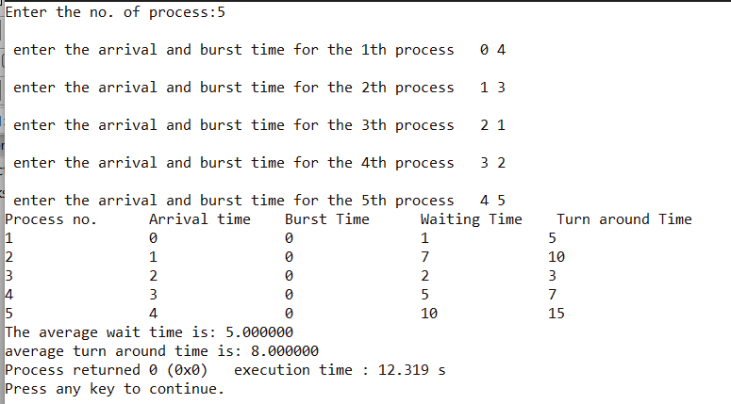}

**PROBLEM NUMBER : 10**

**(PREEMPTIVE)**

**PROGRAM:**

#include <stdio.h> // Name: Sonali Kumari

int main() // Rollno. : 39

{ // Sec: CE

int n; // Uni Rollno. : 2017381

printf("Enter the no. of process :");

scanf("%d",&n);

int arr[n][3],burst[n];

for(int i=0;i<n;i++)

{

printf("\n enter the arrival,burst time and priority number for the %dth process\t",i+1);

scanf("%d%d%d",&arr[i][0],&arr[i][1],&arr[i][2]);

burst[i]=arr[i][1];

}

int wait[n],tat[n],prev[n];

int t=0,averageTAT=0,averageWait=0;

for(int i=0;i<n;i++)

{

wait[i]=0;

prev[i]=arr[i][0];

}

while(1)

{

int ind=0,mini=100000;

for(int i=0;i<n;i++)

{

if(t>=arr[i][0]&&mini>arr[i][2]&&arr[i][1]>0)

{

mini=arr[i][2];

ind=i;

}

}

if(mini==100000)

break;

arr[ind][1]-=1;

wait[ind]+=t-prev[ind];

t++;

prev[ind]=t;

}

for(int i=0;i<n;i++) {

tat[i]=wait[i]+burst[i];

averageTAT+=tat[i];

averageWait+=wait[i];

}

double a=averageTAT/(1.0*n), b=averageWait/(1.0*n);

printf("Process no.\t Arrival time \t Burst Time\t Priority_no \t Waiting Time \t Turnaround Time\n");

for(int i=0;i<n;i++)

{

printf("%d\t\t %d\t\t %d \t\t %d \t\t%d\t\t%d\n",i+1,arr[i][0],burst[i],arr[i][2],wait[i],tat[i]); }

printf("The average wait time is: %lf \nthe average turn around time is: %lf",b,a);

return 0;

}

**OUTPUT:**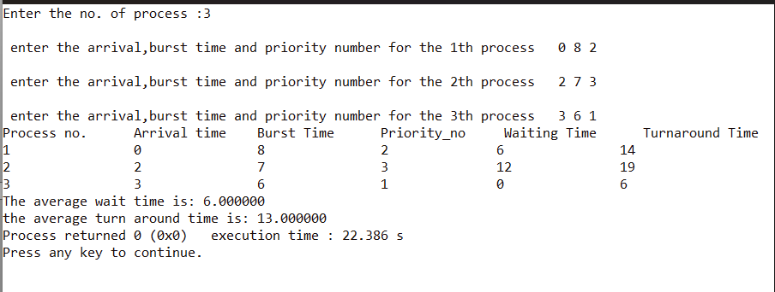

**(NON-PREEMPTIVE)**

**PROGRAM:**

#include <stdio.h> // Name: Sonali Kumari

void sort(int a[][3],int n) // Rollno. : 39

{ // Sec: CE

for(int i=0;i<n;i++) // Uni Rollno. : 2017381

{ for(int j=i+1;j<n;j++)

{ if(a[i][2]<a[j][2])

{ int t=a[i][0];

int k=a[i][1];

int l=a[i][2];

a[i][0]=a[j][0];

a[i][1]=a[j][1];

a[i][2]=a[j][2];

a[j][0]=t;

a[j][1]=k;

a[j][2]=l;

}

}

} }

int main(){

int n;

printf("Enter the no. of process :");

scanf("%d",&n);

int arr[n][3];

for(int i=0;i<n;i++)

{ printf("\n enter the arrival,burst time and priority number for the %dth process\t",i+1);

scanf("%d%d%d",&arr[i][0],&arr[i][1],&arr[i][2]);

}

sort(arr,n);

int wait[n],tat[n],averageWait=0,averageTAT=0;

wait[0]=0;

for(int i=1;i<n;i++){

wait[i]=wait[i-1]+arr[i-1][1];

averageWait+=wait[i];

}

for(int i=0;i<n;i++) {

tat[i]=wait[i]+arr[i][1];

averageTAT+=tat[i];

}

double a=averageTAT/(1.0*n), b=averageWait/(1.0*n);

printf("Process no.\t Arrival time \t Burst Time\t Priority_no \t Waiting Time \t Turn around Time\n");

for(int i=0;i<n;i++)

{ printf("%d\t\t%d\t\t%d\t\t%d\t\t%d\t\t%d\n",i+1,arr[i][0],arr[i][1],arr[i][2],wait[i],tat[i]);

}

printf("The average wait time is: %lf \nthe average turn around time is: %lf",b,a);

return 0;

}

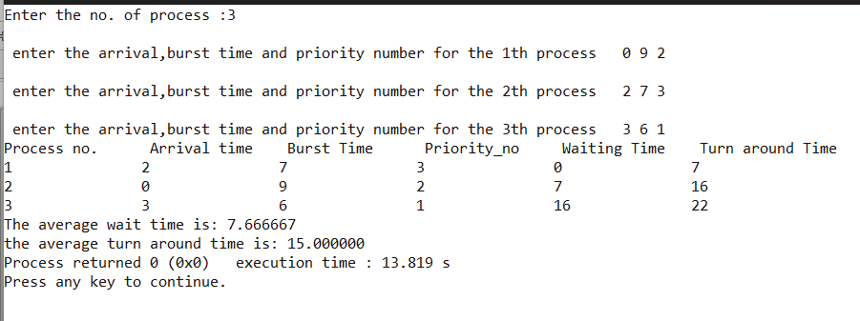**OUTPUT:**

**PROBLEM NUMBER : 11**

**PROGRAM:**

#include <stdio.h> // Name: Sonali Kumari

#include <stdlib.h> // Rollno. : 39

#define MAX 5 // Sec: CE

int front = 0, back = -1, cs = 0, nf; // Uni Rollno. : 2017381

int f[MAX];

void enq(int x);

void deq(void);

void dis(void);

int isfound(int);

void main()

{

int pf = 0, rfs, rf[15], i;

printf("\n FIFO page replacement");

printf("\n Enter the size of reference string:");

scanf("%d", &rfs);

printf("\n Enter the reference string:");

for (i = 0; i < rfs; i++)

{

scanf("%d", &rf[i]);

}

printf("\n Enter the number of free frames:");

scanf("%d", &nf);

enq(rf[0]);

pf = 1;

for (i = 0; i < rfs; i++)

{

if (!isfound(rf[i]))

{

pf++;

if (cs == nf)

deq();

enq(rf[i]);

}

dis();

}

printf("\n No of page faults :%d", pf);

}

int isfound(int x)

{

int i;

for (i = 0; i < cs; i++)

if (f[i] == x)

return 1;

return 0;

}

void enq(int x)

{

if (++back == nf)

back = 0;

f[back] = x;

cs++;

}

void dis()

{

int i;

for (i = 0; i < cs; i++)

printf("%d", f[i]);

printf("\n");

}

void deq()

{

cs--;

if (++front == nf)

front = 0;

return;

}

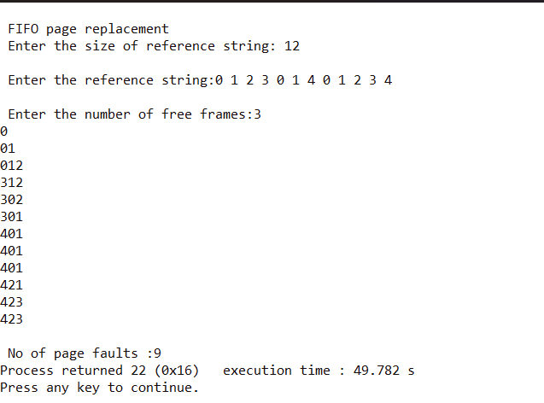 **OUTPUT:**

**PROBLEM NUMBER : 12**

**PROGRAM:**

#include <stdio.h> // Name: Sonali Kumari

#include <stdlib.h> // Rollno. : 39

#include <conio.h> // Sec: CE

int fsize, ssize, f, frame[10], arrive[30], rstring[30]; // Uni Rollno. : 2017381

int main()

{

int i, lfi, idx, cs = 0, f, ls = 0, pf = 0, j = 0, y, k, z = 0, time = 0;

int pagefound(int x);

void display();

int leastused();

int pagelocation(int x);

printf("\n\n\t\t LRU PAGE REPLACEMENT");

printf("\n\t\t --------------------");

printf("\n\n\t Enter the frame size:");

scanf("%d", &fsize);

printf("\n\t Enter the reference string size:");

scanf("%d", &ssize);

printf("\n\t Enter the reference string:");

for (i = 0; i < ssize; i++)

scanf("%d", &rstring[i]);

for (k = 0; k < fsize; k++)

{ frame[k] = -3;

arrive[k] = 0;

} for (i = 0; i < ssize; i++) {

y = pagefound(rstring[i]);

if (y == 0)

{ pf++;

if (cs >= fsize)

{ lfi = leastused();

frame[lfi] = rstring[i];

arrive[lfi] = ++time;

}

else if (cs < fsize)

{ frame[cs] = rstring[i];

arrive[cs] = ++time;

}

}

else

{

idx = pagelocation(rstring[i]);

arrive[idx] = ++time;

}

cs++;

display();

}

printf("\n Page fault=%d", pf);

}

int pagefound(int x)

{

int i, val = 0;

for (i = 0; i < fsize; i++)

{

if (x == frame[i])

{

val = 1;

break;

}

}

return (val);

}

void display()

{

int i;

printf("\n");

for (i = 0; i < fsize; i++)

{

if (frame[i] >= 0)

{

printf("%d", frame[i]);

}

else

printf("\t");

}

}

int leastused()

{

int i, min = 0, n = 0;

for (i = 1; i < fsize; i++)

{

if (arrive[i] < arrive[min])

{

min = i;

n++;

}

}

if (n == 0)

return (0);

else

return (min);

}

int pagelocation(int pageno)

{

int i, flag = 0;

for (i = 0; i < fsize; i++)

{

if (frame[i] == pageno)

{

flag = 1;

break;

}

}

return (i);

}

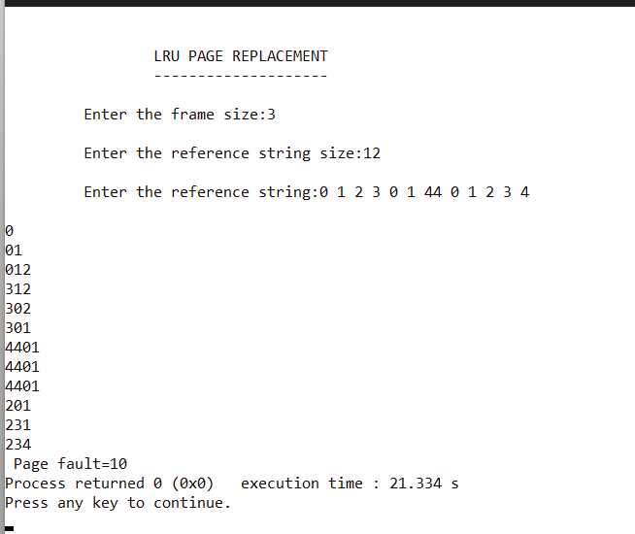 **OUTPUT:**

**PROBLEM NUMBER : 13**

**PROGRAM:**

#include <stdio.h> // Name: Sonali Kumari

int main() // Rollno. : 39

{ // Sec: CE

int n, pg[30], fr[10]; // Uni Rollno. : 2017381

int count[10], i, j, k, fault, f, flag, temp, current, c, dist, max, m, cnt, p, x;

fault = 0;

dist = 0;

k = 0;

printf("Enter the total no pages:");

scanf("%d", &n);

printf("Enter the sequence:");

for (i = 0; i < n; i++)

scanf("%d", &pg[i]);

printf("\nEnter frame size:");

scanf("%d", &f);

for (i = 0; i < f; i++)

{

count[i] = 0;

fr[i] = -1;

}

for (i = 0; i < n; i++)

{

flag = 0;

temp = pg[i];

for (j = 0; j < f; j++)

{

if (temp == fr[j])

{

flag = 1;

break;

}

}

if ((flag == 0) && (k < f))

{

fault++;

fr[k] = temp;

k++;

}

else if ((flag == 0) && (k == f))

{

fault++;

for (cnt = 0; cnt < f; cnt++)

{

current = fr[cnt];

for (c = i; c < n; c++)

{

if (current != pg[c])

count[cnt]++;

else

break;

}

}

max = 0;

for (m = 0; m < f; m++)

{

if (count[m] > max)

{

max = count[m];

p = m;

}

}

fr[p] = temp;

}

printf("\npage %d frame\t", pg[i]);

for (x = 0; x < f; x++)

{

printf("%d\t", fr[x]);

}

}

printf("\nTotal number of faults=%d", fault);

return 0;

}

**OUTPUT:**

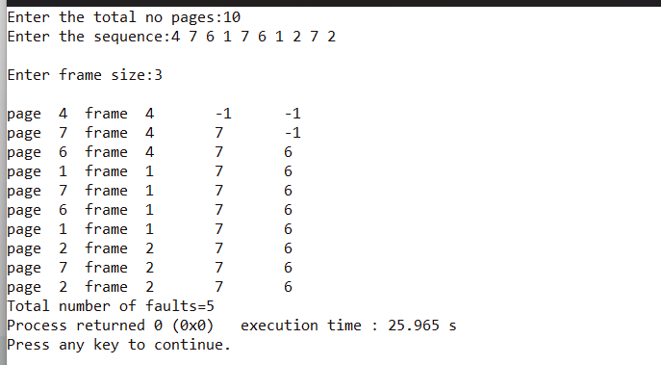**PROBLEM NUMBER : 14**

**PROGRAM:**

#include <stdio.h> // Name: Sonali Kumari

int main(){ // Rollno. : 39

int initial,n; // Sec: CE

printf("enter the initial position of the head and the no. of tracks to be reached :");

scanf("%d%d",&initial,&n); // Uni Rollno. : 2017381

printf("enter the disk track numbers to be reached\n");

int arr[n];

for(int i=0;i<n;i++)

{

scanf("%d",&arr[i]);

}

int total=initial-arr[0];

if(total<0)

total*=-1;

for(int i=0;i<n-1;i++)

{ int a=arr[i]-arr[i+1];

if(a<0)

a*=-1;

total+=a; }

printf("The total amount is %d",total);

return 0;

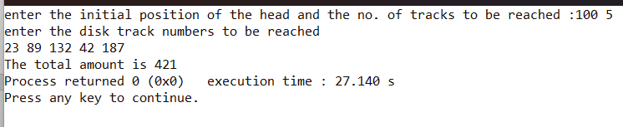} **OUTPUT:**

**PROBLEM NUMBER : 15**

**PROGRAM:** // Name: Sonali Kumari

#include <stdio.h // Rollno. : 39

int main(){ // Sec: CE

int initial,n; // Uni Rollno. : 2017381

printf("enter the initial position of the head and the no. of tracks to be reached:");

scanf("%d%d",&initial,&n);

printf("enter the disk track numbers to be reached\n");

int arr[n];

for(int i=0;i<n;i++)

{

scanf("%d",&arr[i]);

}

int c=0,total=0;

while(c!=n)

{ int d=10000,ind;

for(int i=0;i<n;i++)

{ int l=initial-arr[i];

if(l<0)

l*=-1;

if(l<d)

{ d=l;

ind=i;

}

}

initial=arr[ind];

arr[ind]=10000;

total+=d;

c++;

}

printf("The total amount is %d",total);

return 0;

}

**OUTPUT:**